Step 1
Imported the sample data using nano command in salesman.csv, customer.csv and orders.csv

Step 2
Created Metadata for respective csv ( salesman.csv, customer.csv and orders.csv )
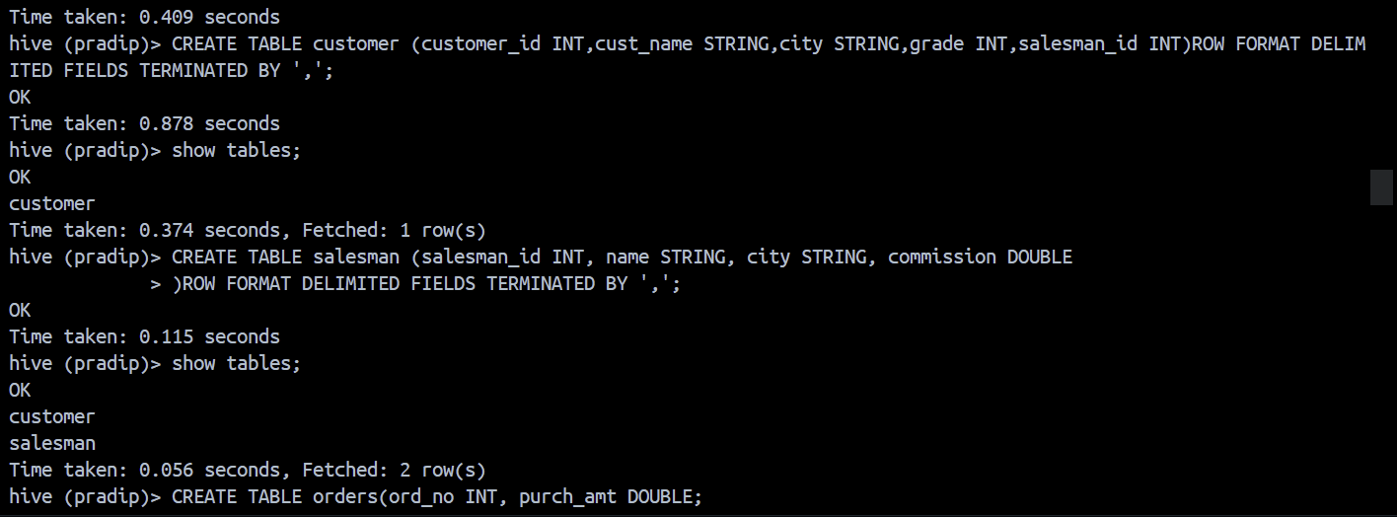

Step 3
Loaded data from the path where we copy pasted provided data using nano command
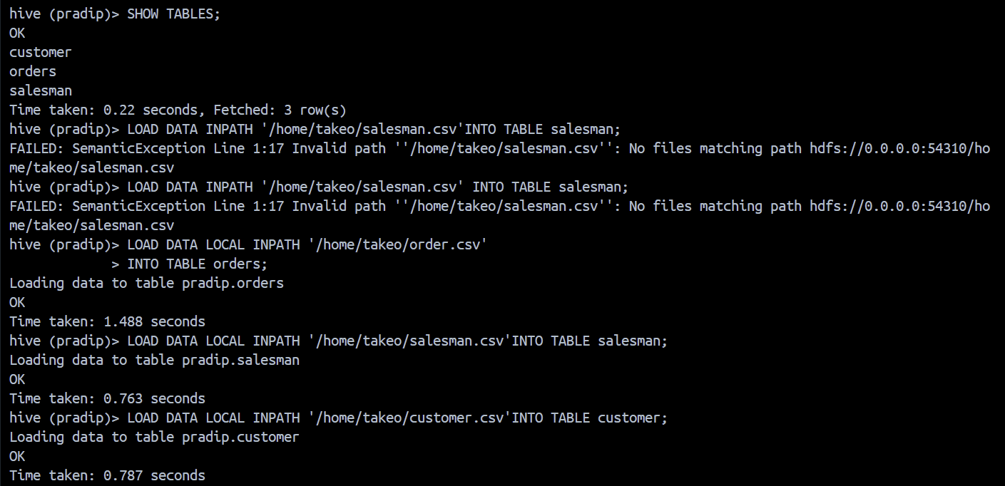
To solve the given Questions using SQL in Hive
Que 1)
Write a SQL statement to prepare a list with salesman name, customer name and their cities for the salesmen and customer who belongs to the same city.

Solution SQL Statement

Result of the Query
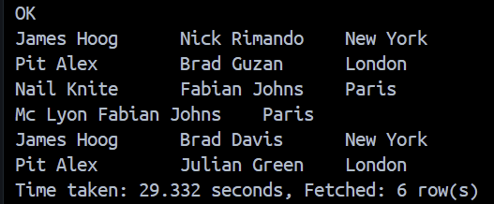

Que 2)
Write a SQL statement to know which salesman are working for which customer.
Solution SQL statement

Result of the Query
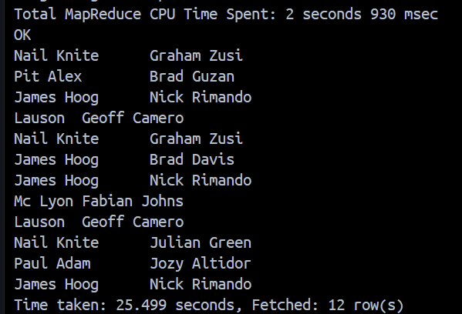

Que 3)
Write a SQL statement to make a list with order no, purchase amount, customer name and their cities for those orders which order amount between 500 and 2000.

Solution SQL statement
Result of the Query
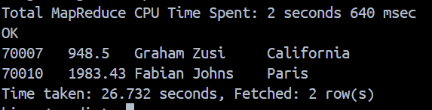

Que 4)
Write a SQL statement to find the list of customers who appointed a salesman for their jobs who gets a commission from the company is more than 12%.

Solution SQL statement

Result of the Query
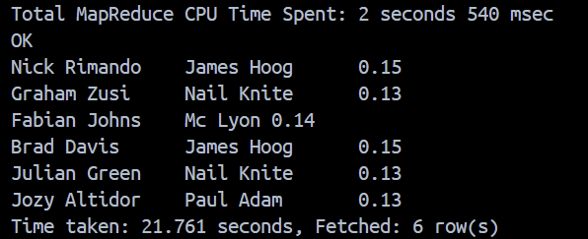

Que 5)
Write a SQL statement to find the list of customers who appointed a salesman for their jobs who does not live in the same city where their customer lives, and gets a commission above 12% .

Solution SQL statement

Result of the Query
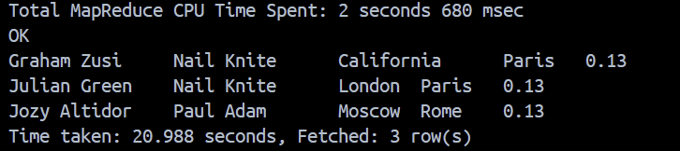

Section 2
Replace ? with appropriate delimiter according to the given data in below create table sql
Q(1)
Step 1(i): Created the complex table metadata
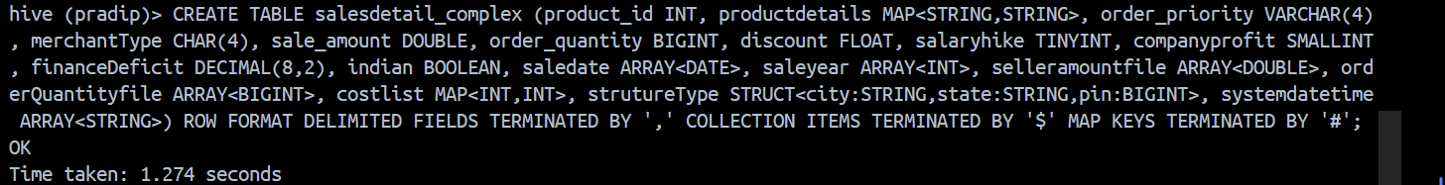
Here we have delemiters
, separates columns
$ separates items inside arrays/maps
# separates map key and value

Step 1 (ii) Checking create table using DESC

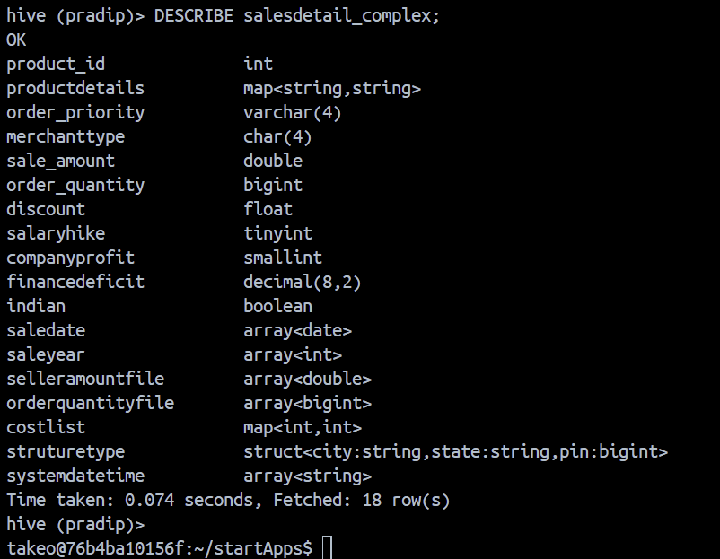
Step 2(i): Loaded the provided data of 5 sample records using nano command
Exited hive to make sure we are in the (local file system instead of hive) home directory /home/takeo and loaded provided data using nano command

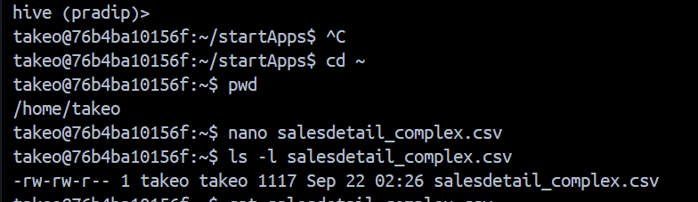

Q(2)
Step 2(ii): Entered HIVE and loaded data from the local home location and viewed it

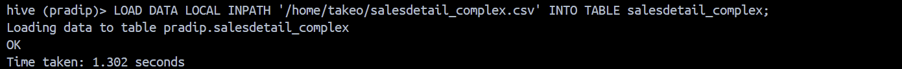

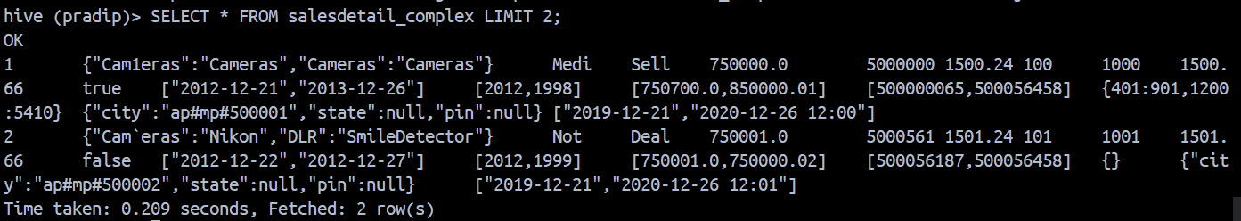

Q(3)
Step 3(i): Create table non_part
My data is separated by ‘|’ instead of ,

Step 3(ii) Inserted the provided data outside hive (in local location) using nano command
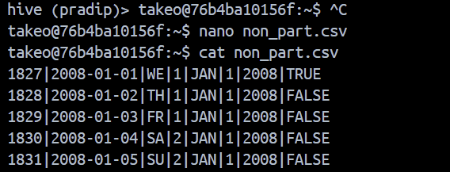

And loaded that data in to hive
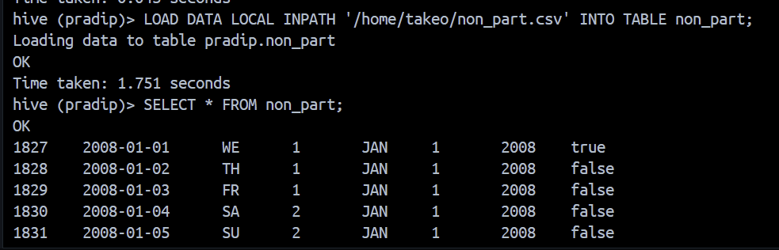

Q(4)
Ans
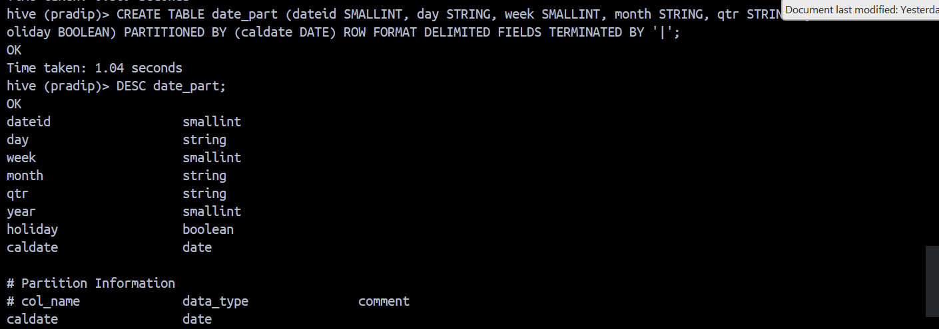

Q(5)
Ans
